Standard | Items:
2.OA.01 -  Use addition and subtraction within 100 to solve one- and two-step word problems involving situations of adding to, taking from, putting together, taking apart, and comparing, with unknowns in all positions, e.g., by using drawings and equations with a symbol for the unknown number to represent the problem | 3.0 Solve the problem and show your work.  A. Sam had 44 Legos. His mom gave him 23 more. The next day, Sam got 16 more Legos. How many Legos does Sam have now?  B. Kate was playing with her Legos. She used 14 of them to build a tower. Now she has 12 Legos left. How many Legos did Kate start with?  C. Matt has 76 Legos and Bill has 55 Legos. How many more Legos does Matt have than Bill?  D. Which equation shows taking from?  E. Which equation shows putting together?
2.0

1. Match the following terms that are alike. Draw a line to show.

Putting together Taking apart

Taking from Adding to

2. Order the numbers from least to greatest.

23, 12, 8, 45,

______ _______ ______ _______

3. Put the symbol that shows what operation you use for these terms. Use the (+) or minus (-) sign below.

Taking apart
Adding to
Putting together
Taking from

2.NBT.07 -  Add and subtract within 1000, using concrete models or drawings and strategies based on place value, properties of operations, and/or the relationship between addition and subtraction; relate the strategy to a written method. Understand that in adding or subtracting three- digit numbers, one adds or subtracts hundreds and hundreds, tens and tens, ones and ones; and sometimes it is necessary to compose or decompose tens or hundreds. | 3.0  Solve and show your thinking  - 24+32=_____  - 45 -12= _____  - 135 - I I = _____  - Pat solved this problem.  - 123+114  123=100+20+3  114=100+10+4  100+100+200  20+ 10= 30  3+4=7  200+30+7=237  Pat has decomposed to solve the problem. Help Pat by circling a where he where he decomposed.
2.0
- What number does this model show [_] III …= _____
- What number is made up of two ten and three ones? ________
- Solve and show your thinking 42+23= _____
- Solve and show your thinking 54-21= _____
- 128 - I I :. = _____
- Show two ways to decompose 12
  - _______
  - _______
- Did this person decompose when solving the problem? Circle: Yes or No

124- 11= 113

124-10=114
114-1=113

2.NBT.07 -  Add and subtract within 1000, using concrete models or drawings and strategies based on place value, properties of operations, and/or the relationship between addition and subtraction; relate the strategy to a written method. Understand that in adding or subtracting three- digit numbers, one adds or subtracts hundreds and hundreds, tens and tens, ones and ones; and sometimes it is necessary to compose or decompose tens or hundreds. | 3.0  Word Bank:  Use a Model (base ten blocks, place value chart or number line)  Place Value (decompose or break apart)  Make a Drawing (picture)  Make a Ten  Adding up  - The class has 86 pencils to share. If 24 pencils are used, how many pencils are left? Solve. Show your thinking and name the strategy you used.  - The principal found 10 more pencils and gave them to the class. How many pencils do they now have to use?
2.0

Word Bank:
Use a Model (base ten blocks, place value chart or number line)
Place Value (decompose or break apart)
Make a Drawing (picture)
Make a Ten
Adding up

- Bobby solved 23+16 by saying that 20+10=30 and 3+6= 9, then 30+9=39. So he knew that the answer was 39. Name the strategy that Bobby used to solved the problem. _______________
- Solve 154 + 38 = ________
- 68 - 26 = _____________
- Use the model. Take 44 away from the number below, how much is left? ___________

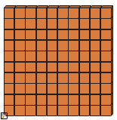

2.MD.07 -  Tell and write time from analog and digital clocks to the nearest five minutes, using a.m. and p.m. Know relationships of time (eg. minutes in an hour, days in a month, weeks in a year.) CA | 3.0  My sister and I played after school at 3:30. Write what time we were there on the clock below. Circle A.M. or P.M.  A. 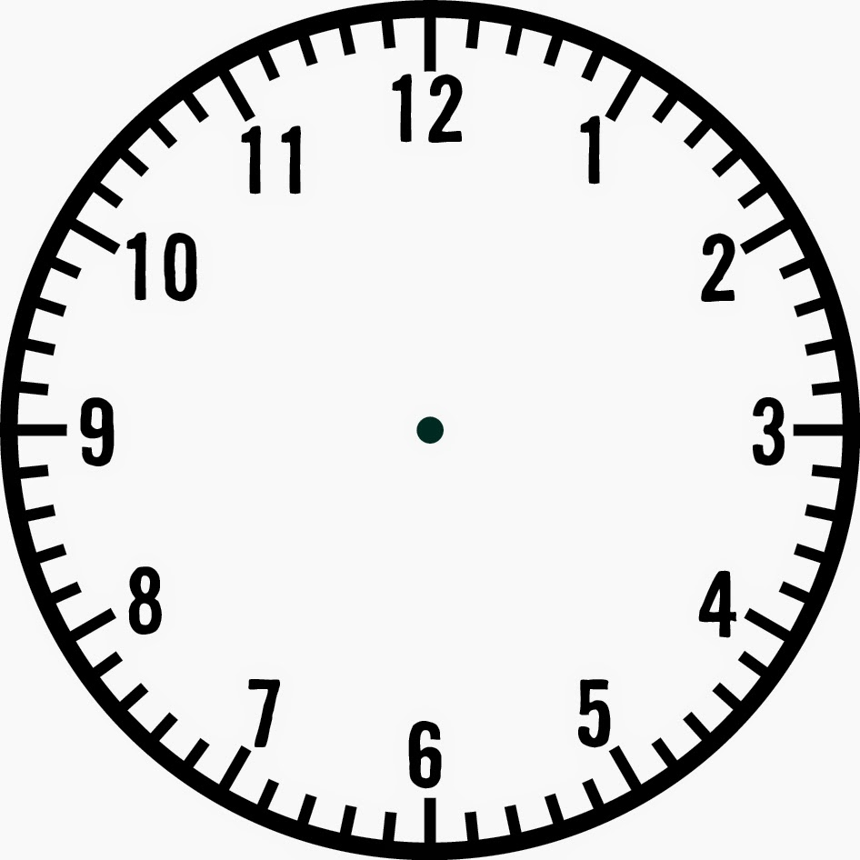 A.M. P.M.  B. How many minutes are in an hour? _______________
2.0
- Draw a line to match the time on the analog clock to the digital clock.

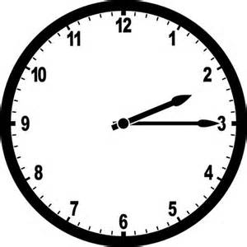 11:40
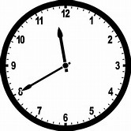 5:00
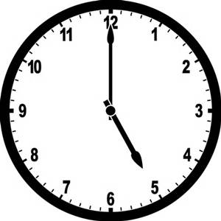 2:15

- Write the time in words.
- 4:00 _______________________
- 1:30 _______________________

- Draw the hands on the analog clock to show the time.

1:15

4. Write the time on the digital clock.

5. Taylor has swim practice after school. Practice begins at 3:30. Is the time a.m. or p.m.?

- p.m. b. a.m.

6. Is the time,
quarter till 7:00
quarter after 7:00

7. How many days are there in a week? ___________

8. How many minutes in an hour? _____________

2.NBT.04 -  Compare two three-digit numbers based on meanings of the hundreds, tens, and ones digits, using >, =, and < symbols to record the results of comparisons. | - 4. Order the numbers from greatest to least:  - 762, 276, 726, 672  _____________ _____________ ____________ _____________  - Use the chart below to show how many hundreds, tens, and ones you see:  - 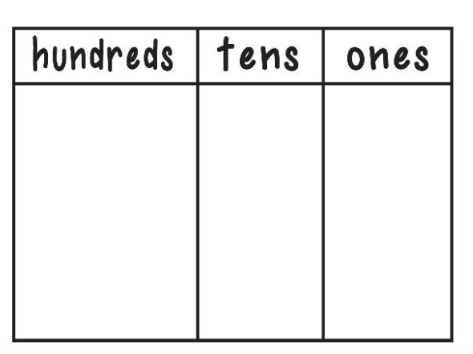  6. Carol is playing a game and draws three cards:  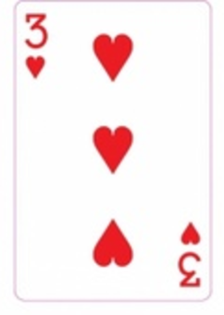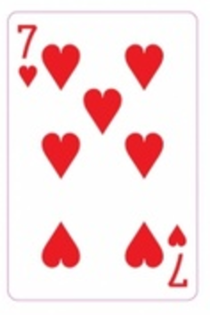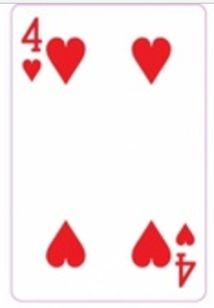  - a. What is the greatest 3-digit number Carol can make using all three cards?  _____ _____ _____  b. Matthew made the number 371. Compare the number that Carol made and the number that Matthew made by using the symbols >, <, or =.  ________ _________  c. Use place value to explain why you used the symbol above.  _________________________________________________________________________________________________  - 123 ____ 321  - Which number is greater? 123 or 321?  - Mary has 123 red marbles, 214 yellow marbles, 321 blue marbles. Show the comparison between red marbles blue marbles. ______ _______  - Compare the numbers. Mary has a collection of diamond back marbles. She has 123 red marbles and 321 blue marbles. Show the comparison between her marbles.

